**We’re Exhibiting at SMTA international 2025**

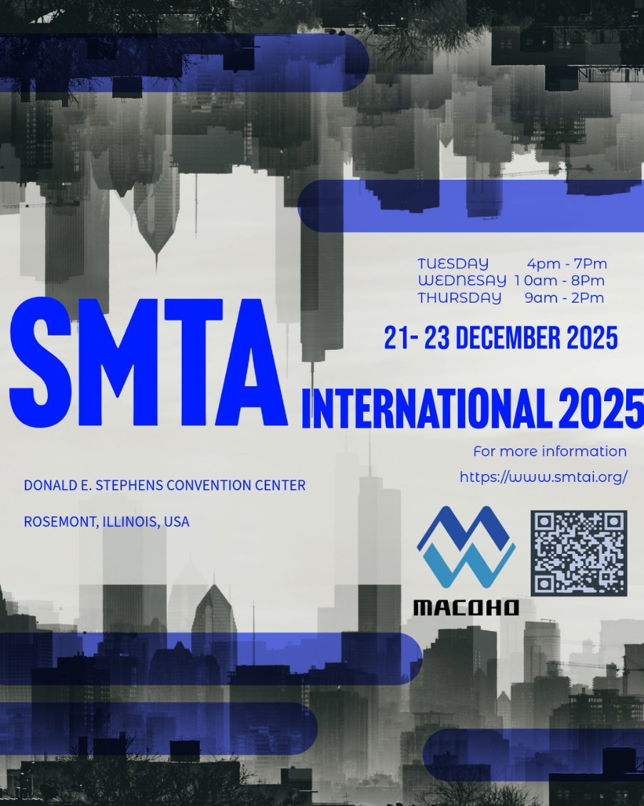

**About SMTA International 2025**

SMTA International 2025 is one of the premier events in the electronics manufacturing and assembly industry, bringing together professionals, innovators, and decision-makers in manufacturing, test, inspection, reliability, packaging, and process improvement — a flagship gathering where companies can showcase technology, meet prospects, build brand recognition, and connect with leading experts in the electronics manufacturing ecosystem.

**Conference / Technical Program**: The event includes a technical conference with multiple tracks (additive electronics, advanced packaging, low-temperature solder, manufacturing excellence, harsh environment reliability, test & inspection)

**Audience / Reach**: Attendees include engineers, production managers, R&D, quality, operations, and suppliers from across the electronics supply chain. The expo is a major hub for networking, lead generation, new product launches, and showcasing innovations in electronics manufacturing.

**Dates & Location**: October 19–23, 2025, at the Donald E. Stephens Convention Center, Rosemont, Illinois, USA

**Expo / Exhibition**: October 21–23, 2025 (during the show, there is an exhibition component)   
  
**Our booth number:** 3048

For more information about this event, please visit [SMTA International | Electronics Manufacturing Conference | Donald E. Stephens Convention Center, North River Road, Rosemont, IL, USA](https://www.smtai.org/) or scan the QR code.